Indian Journal of Surgical Oncology (June 2018) 9(2):187–191 https://doi.org/10.1007/s13193-018-0755-5



Surgical Management of Head and Neck Soft Tissue Sarcoma: 11-Year Experience at a Tertiary Care Centre in South India

Nivedita Sharma1 & Nebu Abraham George1 & Rajesh Singh1 & Elizabeth Mathew Iype1 & Bipin T Varghese1 & Shaji Thomas1

Received: 29 March 2017 /Accepted: 10 April 2018 /Published online: 20 April 2018

# Indian Association of Surgical Oncology 2018

Abstract

Head and neck soft tissue sarcoma (HNSTS) is a rare neoplasm accounting for 1% of all head and neck tumours. Because of rarity and varied biological behaviour among various subtypes, knowledge about these tumours is limited. This study aimed at analysing clinicopathological, recurrence and survival pattern of surgically treated HNSTS. Case records of 28 patients of HNSTS who underwent surgery at the Regional Cancer Centre (RCC), Trivandrum (India) between 2002 and 2012 were analysed retrospectively for demographic profile, clinical features, treatment given, recurrence pattern and outcome. The median age of patients was 37 years (range, 3–79) with male:female ratio of 3:2. Majority of patients presented with painless lump in the neck as the most common subsite affected followed by scalp and face. One patient had nodal disease, while none had distant metastasis at presentation. The most frequent histological subtypes were synovial sarcoma and fibrosarcoma followed by malignant fibrous histiocytoma, angiosarcoma and rhabdomyosarcoma. Majority (78.5%) of patients received adjuvant therapy in the form of radiation, chemotherapy or chemo-radiation. After mean follow-up of 49 months, four patients had died, and six developed local recurrence and four distant metastasis. The overall 5-year survival was 82.7% while 5-year disease-free survival was 55.3%. HNSTS is a rare entity that requires multimodality treatment to achieve optimum locoregional control and survival.

Keywords Head and neck . Soft tissue sarcoma . Surgical management . Mutimodality treatment . Locoregional control and

survival

# Introduction

Soft tissue sarcoma (STS) is a rare neoplasms accounting for 1% of all solid neoplasm, with head and neck sarcomas representing only 2–15% of all sarcomas. Among head and neck tumours (H&N), they account for less than 1% [1, 2].

Soft tissue sarcoma has biphasic age distribution with 80– 90% occurring in adults and 10–20% in paediatric age group. As compared to squamous cell cancer of H&N region, STS affects comparatively younger population with mean age of 49 [1, 3]. In majority of the patients, tumour manifests itself as a painless lump. A variety of other symptoms like dysphagia,

|  |
| --- |
| * Nivedita Sharma nivsha1985@gmail.com  1  Surgical Oncology Division, Regional Cancer Centre,  Trivandrum 695011, India |

dyspnea, otalgia, nasal blockage and epistaxis can occur depending on site of head and neck region affected [3, 4].

Optimal treatment for most STS is complete resection; however, ability to obtain wide surgical margins is limited due critical anatomy of the head and neck. This may be a reason for higher local recurrence (LR) and poor diseasefree survival (DFS) in these tumours [5, 6]. Postoperative adjuvant radiotherapy should be offered to those with positive or close margin, as well as to those with high-grade tumours. The role of adjuvant chemotherapy is not clearly defined.

Our knowledge of these tumours is restricted because of their rarity along with different subtypes associated with varied clinical behaviour and response to treatment.

This is a retrospective analysis of patients with histologically proven soft tissue sarcoma of head and neck (HNSTS) who underwent surgical treatment in surgical oncology department of the Regional Cancer Centre, Trivandrum, over a period of 11 years (2002–2012).

|  |
| --- |
| Indian J Surg Oncol (June 2018) 9(2):187–191 |

# Patients and Methods

Between January 2002 and December 2012, 28 patients with HNSTS who underwent surgery at the Regional Cancer Centre, a tertiary care centre in south India, comprised the study group. The case records of these patients were analysed in detail for demographic profile, clinical features, treatment given and outcome. All of these patients underwent surgical resection of primary tumour. Neck dissection was done in patients with clinically significant node or with suspicious nodes found intraoperatively. Postoperative histopathology reports were reviewed and histopathological factors like histopathological subtype, grade, surgical margins and tumour size were analysed. Patients have received adjuvant therapy in the form of radiotherapy or chemoradiotherapy based on tumour grade, histopathological subtype, surgical margin and nodal status according to tumour board decision. The patients were regularly followed up by clinical and, if needed, imaging with every 3 months for the initial 2 years and every 6 months thereafter to monitor for any recurrence of disease. Survival was calculated out with Kaplan-Meier curves with intention to treat analysis, and influence for variables such as age, tumour size, grade, margin positivity, adjuvant treatment on local and distant recurrence and survival was analysed using univariate analysis.

# Results

## Patient Demographics

The median age of presentation was 37 years (range, 3– 79 years). Of the 28 patients, there were 17 males and 11 females (M:F ratio, 3:2).

## Clinical Presentation

Eighty-two percent of patients presented with progressively enlarging painless lump, with painful lump present only in two patients. Other symptoms included epistaxis, upper limb weakness and eye swelling present in one patient each. In the H&N region, most common subsite was neck (42.8%) followed by scalp and face region (32.1%) and sinonasal tract (10.7%). Other subsites were parotid gland, submandibular gland, mandible and orbit with one patient each. There was no associated family history or history of radiation therapy in any of the patient. However, two patients had history of excision for lipoma and fibrous dysplasia in the past who now presented with liposarcoma and fibrosarcoma respectively. One patient had nodal disease, while none had distant metastasis at the time of presentation.

The most frequent histological subtypes were synovial sarcoma (five cases) and fibrosarcoma (four cases) followed by malignant fibrous histiocytoma, angiosarcoma and rhabdomyosarcoma with three cases each. Other histological subtypes included epitheloid sarcoma, clear cell carcinoma, malignant peripheral nerve sheath tumour, liposarcoma, pleomorphic sarcoma and extraosseous Ewing sarcoma. There were four patients (14%) with malignant spindle cell sarcoma in which further histological typing was not possible (Table 1)

Based on tumour size, 13 (46.4%) cases were T1 while 15 (53.5%) were of T2 stage. Clinically, nodal disease was found in only one patient. Using three-tier grading system, 9 cases were of high grade’ 13 were of intermediate grade and 3 were of low grade. No grade was mentioned in histopathology report of the three cases

(Table 2).

|  |  |  |  |  |  |  |
| --- | --- | --- | --- | --- | --- | --- |
| Histology | Site |  |  |  |  |  |
| Neck | Face and  scalp | Sinonasal tract | Salivary gland | Other | Total |
| Fibrosarcoma | 2 | 1 | 0 | 0 | 1 | 4 |
| Synovial sarcoma | 3 | 1 | 0 | 1 | 0 | 5 |
| Malignant fibrous histiocytoma | 1 | 2 | 0 | 0 | 0 | 3 |
| Rhabdomyosarcoma | 1 | 1 | 0 | 0 | 1 | 3 |
| Angiosarcoma | 0 | 2 | 1 | 0 | 0 | 3 |
| Epitheloid sarcoma | 1 | 0 | 0 | 0 | 0 | 1 |
| Clear cell sarcoma | 1 | 0 | 0 | 0 | 0 | 1 |
| MPNST | 0 | 0 | 1 | 0 | 0 | 1 |
| Liposarcoma | 1 | 0 | 0 | 0 | 0 | 1 |
| Pleomorphic sarcoma | 0 | 0 | 0 | 1 | 0 | 1 |
| Extraosseous Ewing sarcoma | 1 | 0 | 0 | 0 | 0 | 1 |
| Malignant spindle cell neoplasm,  NOS | 1 | 2 | 1 | 0 | 0 | 4 |
| Total | 12 | 9 | 3 | 2 | 2 | 28 |

Table 1 Histology and primary

site

Indian J Surg Oncol (June 2018) 9(2):187–191

189

## Outcome

After mean follow-up of 49 months (range, 3–144 months), 17 patients were alive and were disease-free, 3 were alive with disease and 4 succumbed to the disease. Ten (35.7%) of the 28 patients experienced recurrent disease after treatment. Six (21.4%) patients had local recurrence, of which one succumbed to death, four were treated further while one patient defaulted treatment. Of the four, two underwent surgical excision, one received radiation therapy and one received chemotherapy. Four patients developed distant metastasis, all of them in lungs. Three of them received palliative chemotherapywhile one receivedbest supportivecare. Threeofthem died of disease while one was alive with the disease during his last follow-up. No patient had nodal relapse. Interestingly, three of the four patients who developed distant metastasis belonged to synovial sarcoma; however, no such histological correlation could be found with locoregional recurrences. Four patients were lost to follow-up after receiving primary surgical treatment while one patient defaulted after detection of recurrence. Time to development of local and distant recurrence ranged from 2 months to 2.75 years and 2 months to 3.6 years respectively. The 5-year OS was 82.7% whereas 5-year DFS was 55.3%.

Several factors like age, gender, grade, size, margin status and adjuvant therapy were analysed for prognostic influence on disease recurrence and overall survival. On univariate analysis, tumour size < 4 cm was found to have significantly better disease-free survival (P = 0.02) and overall survival (P = 0.05) (Fig. 1). There was also trend towards better DFS and OS with low grade and negative margin; however, difference could not reach statistical significance. No significant influence of above variables was found on LR. However, 50% of patients who did not receive adjuvant treatment developed LR as compared to 14% in adjuvant therapy group (P = 0.005).

# Discussion

Sarcomas are malignant neoplasm arising from mesodermal tissues and constitute less than 1% of body tumours, including those of the head and neck. At MSKCC, in a series of 60 patients, the median age at presentation of HNSTS was 49 years and M:F ratio was 31:29 [3]. Similarly in another study by Panel et al. with 28 patients, median age was 45.7 with M:F ratio of 15:13 [7]. However, in present study, median age was slightly low at 37 years with M:F ratio of 17:11. Commonly encountered HNSTS in various series are synovial sarcoma, rhabdomyosarcoma, malignant fibrous histiocytoma, fibrosarcoma and angiosarcoma [1, 2, 7]. In the present study also, most common histological subtypes were synovial sarcoma and fibrosarcoma, present in 18 and 14% respectively.

|  |  |
| --- | --- |
| Sex |  |
| Male | 17 |
| Female Age at diagnosis | 11 |
| Mean | 35.4 years |
| Median | 37 years |
| Range | 3–79 years |
| < 40 years | 15 |
| > 40 years  Grade | 13 |
| Low grade | 3 |
| Intermediate grade | 13 |
| High grade | 9 |
| Not available  T stage | 3 |
| T1a | 6 |
| T1b | 7 |
| T2a | 2 |
| T2b N stage | 13 |
| N1  Stage grouping | 1 |
| I | 6 |
| II | 15 |
| III  Margins of resection | 7 |
| Negative | 13 |
| Close | 7 |
| Positive | 8 |

Table 2 Patient and disease characteristics

## Treatment

All patients underwent surgical resection as primary modality of treatment. Wide excision was done in all the cases and was combined with hemimandibulectomy in three cases, craniectomy in three cases and maxillectomy in two cases for surgical clearance. Nodal dissection was done in seven patients (25%), in form of selective neck dissection in three, modified radical neck dissection in two while radical neck dissection in two. Of these, only two patients had node positive, with clear cell sarcoma and synovial sarcoma as associated histology. Eight (28.5%) patients required reconstruction after tumour excision in the form of pectoralis major myocutaneous flap, latissimus dorsi flap, trapezius flap and rotation flap.

Twenty-two (78.5%) patients received adjuvant therapy. Radiation therapy alone was given in 11 patients and chemo-radiation in 9 patients. Two patients received only chemotherapy as adjuvant therapy.

190 Indian J Surg Oncol (June 2018) 9(2):187–191

a. Overall Survival b. Disease Free Survival

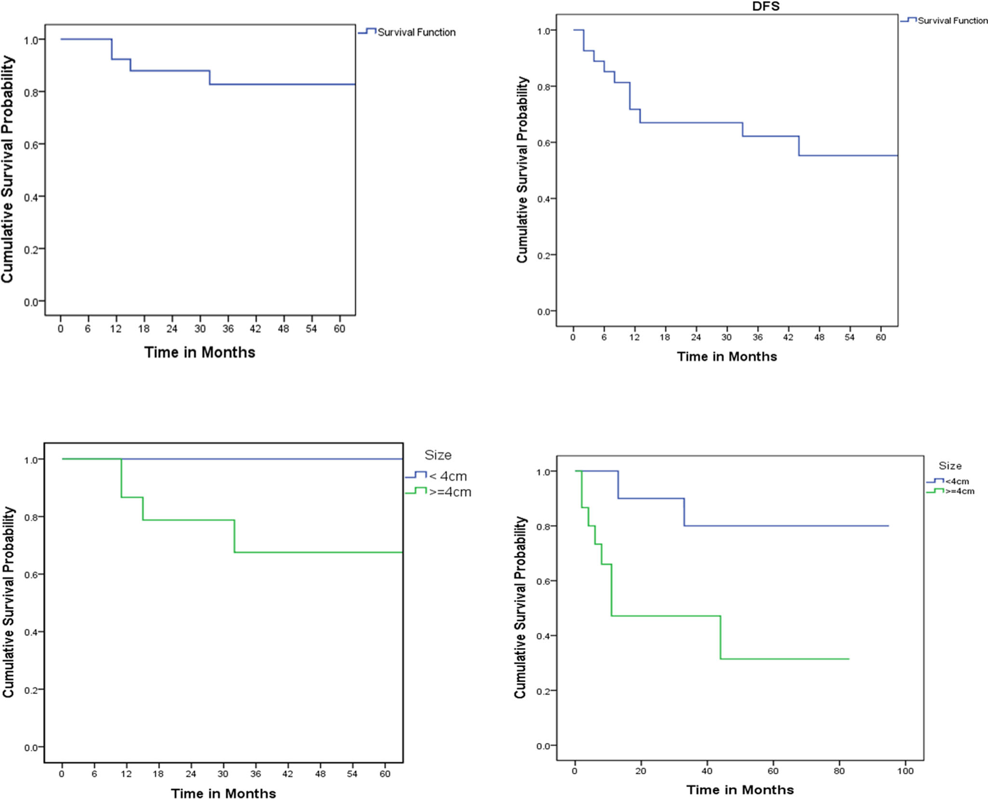

c. Tumor size & OS (univariate analysis)

d. Tumor size & DFS (univariate analysis)

Fig. 1 Tumour size in relation to overall survival and disease-free survival. a, b Overall survival and disease free survival. c, d Tumor size in relation to

overall survival and disease free survival

Similar to other studies, the most common presentation in our study population was painless lump (82%). Though many studies have reported pain as the major symptom in 14–25% [1, 3, 5], in current study, pain was an associated symptom in only 7% of patients.

In the present series, all the patients were treated with surgery as primary modality with or without adjuvant radiotherapy, chemotherapy or both. Unlike STS of other sites, adequate surgical excision is not applicable in most HNSTS due to complex anatomy and proximity to vital structures. In this series, post excision surgical margins were found to be positive in 28.5% patients. Literature data shows a high local failure rate of 40–60%, mainly attributed to difficulty in obtaining wide resection margins [6–8]. In the present study, local failure was present in 21.4% patients. Though previous studies have found association between local failure and surgical margin positivity [3, 7], young age [7] and high grade [3, 9], our study could not find any significant association. But a significant association was found between lack of adjuvant therapy and local recurrence in our study. High percentage of patients who received adjuvant treatment in this study might have been the reason for lack of correlation between margin positivity and local recurrence.

Various studies have reported 5-year OS between 50 and 80% [2, 10, 11]. In current series, 5-year OS was 82.7% while DFS was 55.3%. This may be attributed to majority (78.5%) of patients receiving adjuvant treatment. In a similar study conducted at our centre between 1989 and 2000, 5-year OS was found to be similar (80%), while DFS was 24% [4]. Also survival, both DFS and OS, was found to be better in small tumours (< 4 cm) in this study.

|  |
| --- |
| Indian J Surg Oncol (June 2018) 9(2):187–191 191 |

# Conclusion

HNSTS are rare and heterogeneous group of tumours with different biological behaviours associated with multiple histological subtypes. Surgical excision forms the primary modality of treatment but invariably is associated with high rate of positive or close margin unlike soft tissue sarcomas of other parts. This may result in high local failure rates but when adequately treated with multimodality treatment, results in good overall and disease-free survival.

## Compliance with Ethical Standards

Conflict of Interest The authors declare that there is no conflict of interest.

# References

1. Patel SG, Shaha AR, Shah JP (2001) Soft tissue sarcomas of the head and neck: an update. Am J Otolaryngol 22(1):2–18
2. de Bree R, van der Waal I, de Bree E, René Leemans C (2010) Management of adult soft tissue sarcomas of the head and neck. Oral Oncol 46(11):786–790
3. Kraus DH, Dubner S, Harrison LB, Strong EW, Hajdu SI, Kher U, Begg C, Brennan MF (1994) Prognostic factors for recurrence and survival in head and neck soft tissue sarcomas. Cancer 74(2):697– 702
4. Pandey M, Chandramohan K, Thomas G, Mathew A, Sebastian P, Somanathan T, Abraham EK, Rajan B, Nair MK (2003) Soft tissue sarcoma of the head and neck region in adults. Int J Oral Maxillofac Surg 32(1):43–48
5. Zagars GK, Ballo MT, Pisters PWet al (2003) Prognostic factors for patients with localized soft-tissue sarcoma treated with conservation surgery and radiation therapy: an analysis of 1225 patients. Cancer 97(10):2530–2543
6. Le Vay J, O'Sullivan B, Catton C et al (1994) An assessment of prognostic factors in soft-tissue sarcoma of the head and neck. Arch Otolaryngol Head Neck Surg 120(9):981–986
7. Penel N, Van Haverbeke C, Lartigau E et al (2004) Head and neck soft tissue sarcomas of adult: prognostic value of surgery in multimodal therapeutic approach. Oral Oncol 40(9):890–897
8. Weber RS, Benjamin RS, Peters LJ, Ro JY, Achon O, Goepfert H (1986) Soft tissue sarcomas of the head and neck in adolescents and adults. Am J Surg 152(4):386–392
9. Dudhat SB, Mistry RC, Varughese T, Fakih AR, Chinoy RF (2000) Prognostic factors in head and neck soft tissue sarcomas. Cancer 89(4):868–872
10. Chen SA, Morris CG, Amdur RJ, Werning JW, Villaret DB, Mendenhall WM (2005) Adult head and neck soft tissue sarcomas. Am J Clin Oncol 28(3):259–263
11. Aljabab AS, Nason RW, Kazi R, Pathak KA (2011) Head and neck soft tissue sarcoma. Indian J Surg Oncol 2(4):286–290